**XML--  
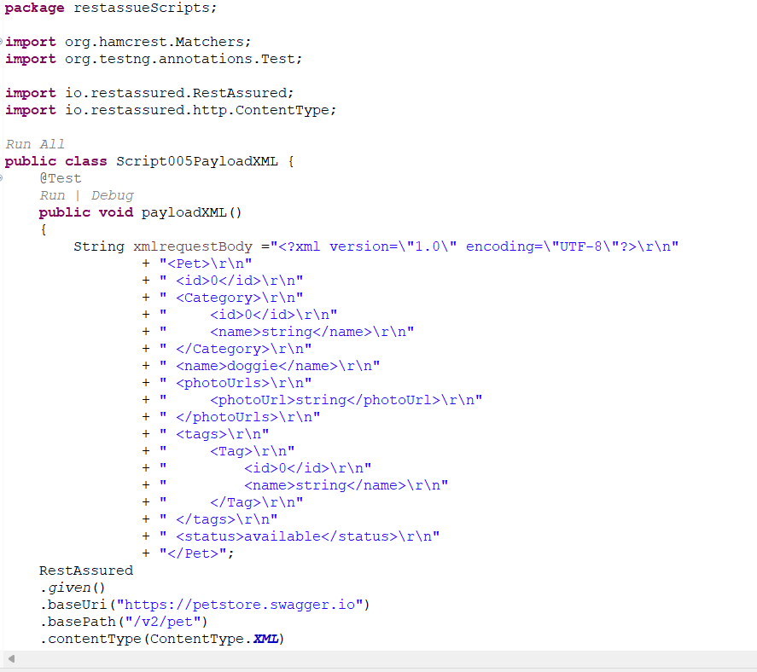**

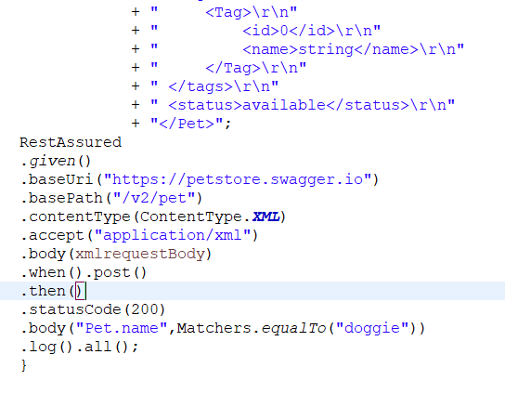

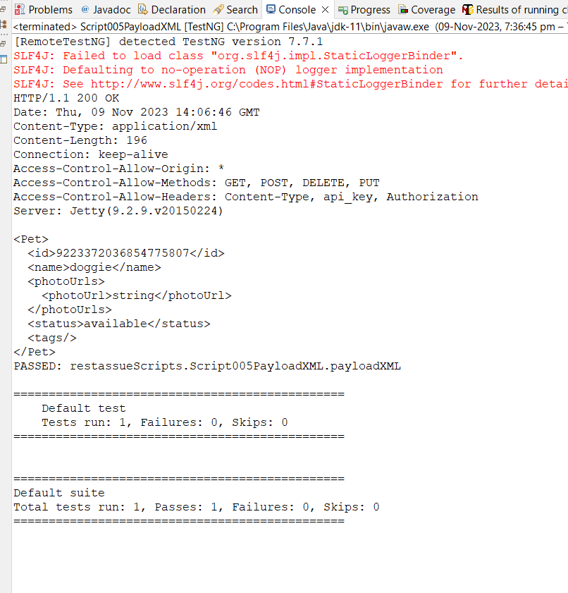

**package** restassueScripts;

**import** org.hamcrest.Matchers;

**import** org.testng.annotations.Test;

**import** io.restassured.RestAssured;

**import** io.restassured.http.ContentType;

**public** **class** Script005PayloadXML {

@Test

**public** **void** payloadXML()

{

String xmlrequestBody ="<?xml version=\"1.0\" encoding=\"UTF-8\"?>\r\n"

+ "<Pet>\r\n"

+ " <id>0</id>\r\n"

+ " <Category>\r\n"

+ " <id>0</id>\r\n"

+ " <name>string</name>\r\n"

+ " </Category>\r\n"

+ " <name>doggie</name>\r\n"

+ " <photoUrls>\r\n"

+ " <photoUrl>string</photoUrl>\r\n"

+ " </photoUrls>\r\n"

+ " <tags>\r\n"

+ " <Tag>\r\n"

+ " <id>0</id>\r\n"

+ " <name>string</name>\r\n"

+ " </Tag>\r\n"

+ " </tags>\r\n"

+ " <status>available</status>\r\n"

+ "</Pet>";

RestAssured

.*given*()

.baseUri("https://petstore.swagger.io")

.basePath("/v2/pet")

.contentType(ContentType.***XML***)

.accept("application/xml")

.body(xmlrequestBody)

.when().post()

.then()

.statusCode(200)

.body("Pet.name",Matchers.*equalTo*("doggie"))

.log().all();

}

}

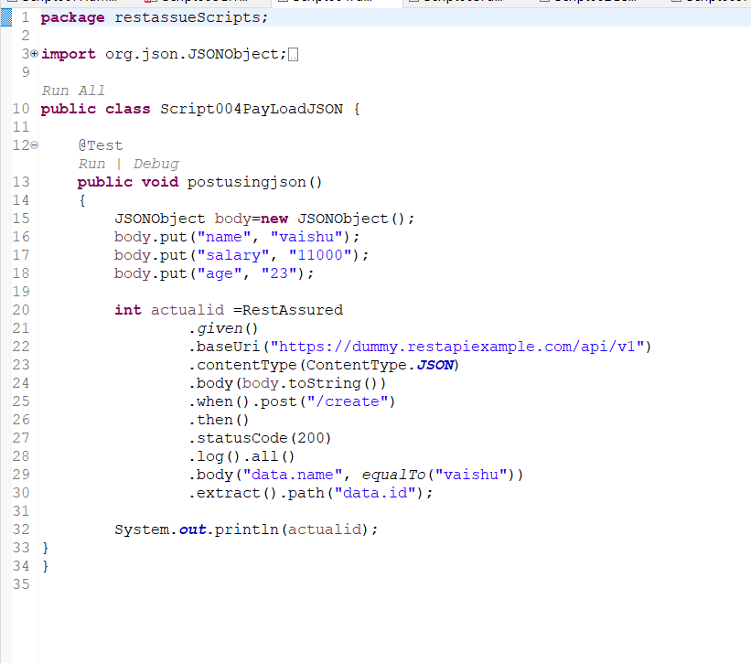

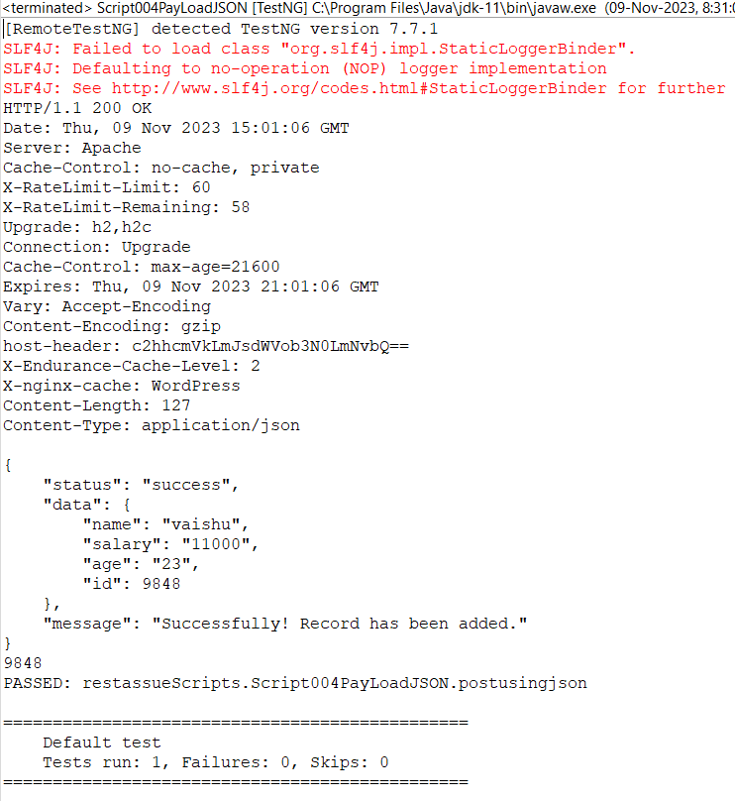

**package** restassueScripts;

**import** org.json.JSONObject;

**import** org.testng.annotations.Test;

**import** **static** org.hamcrest.Matchers.*equalTo*;

**import** io.restassured.RestAssured;

**import** io.restassured.http.ContentType;

**public** **class** Script004PayLoadJSON {

@Test

**public** **void** postusingjson()

{

JSONObject body=**new** JSONObject();

body.put("name", "vaishu");

body.put("salary", "11000");

body.put("age", "23");

**int** actualid =RestAssured

.*given*()

.baseUri("https://dummy.restapiexample.com/api/v1")

.contentType(ContentType.***JSON***)

.body(body.toString())

.when().post("/create")

.then()

.statusCode(200)

.log().all()

.body("data.name", *equalTo*("vaishu"))

.extract().path("data.id");

System.***out***.println(actualid);

}

}